Analysis document for the INCIDENT INC4692481
Issue:
- No output for material S0001020 is not getting displayed in the tcode Z6S0M1_SCMATD
- 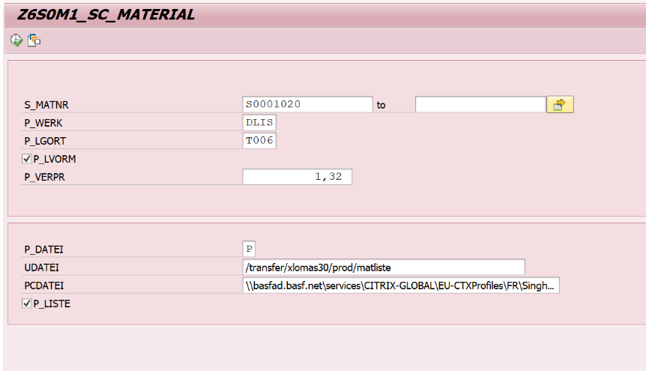
- material 8088442 has double line in output:
- 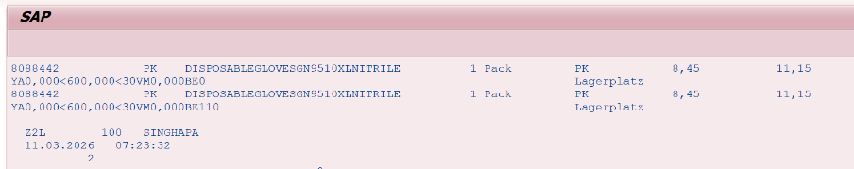
- For the plant DEM1 we still get the price 8,45 only

Analysis: After debugging it is found that for the 1st case the issue is that the particular material is not maintained for English language in MAKT table it is only maintained for German that is why it is not getting displayed for English.
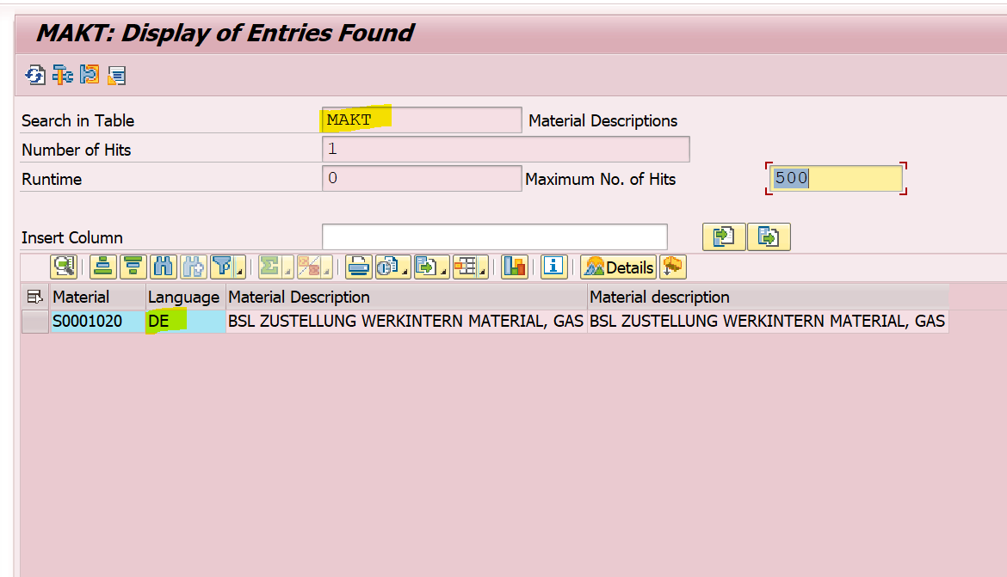
Now for the second scenario the data material and plant is getting fetched from mard as you can see in the below select query also in the where clause there is just for mard there is only plant and sloc no plant
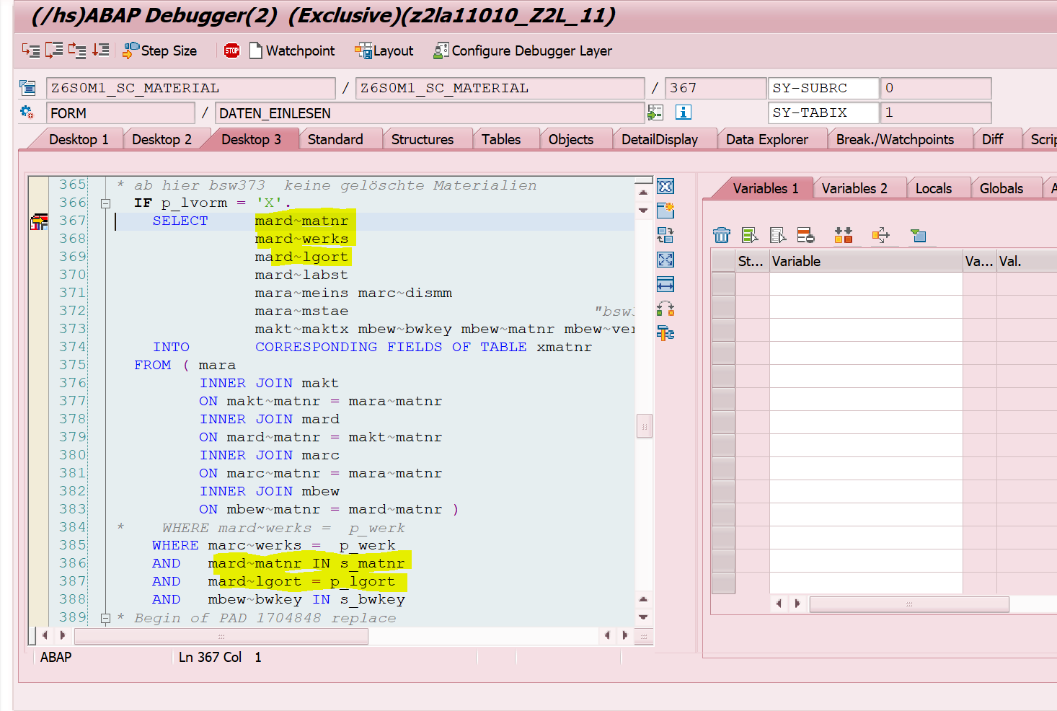
so on the basis of sloc and material we get 2line items from mard.
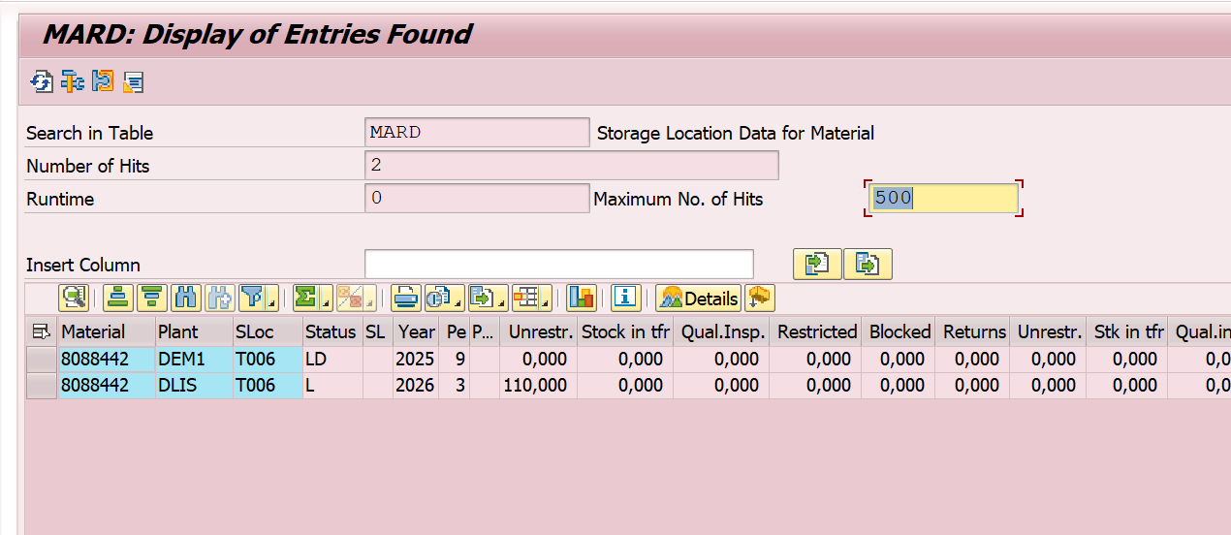
This is how the functionality of the code works.
For the third issue we get price as 8,45 for plant DEM1 because price comes on the basis of valuation area and the valuation area is DLIS which is declared constant in the code.
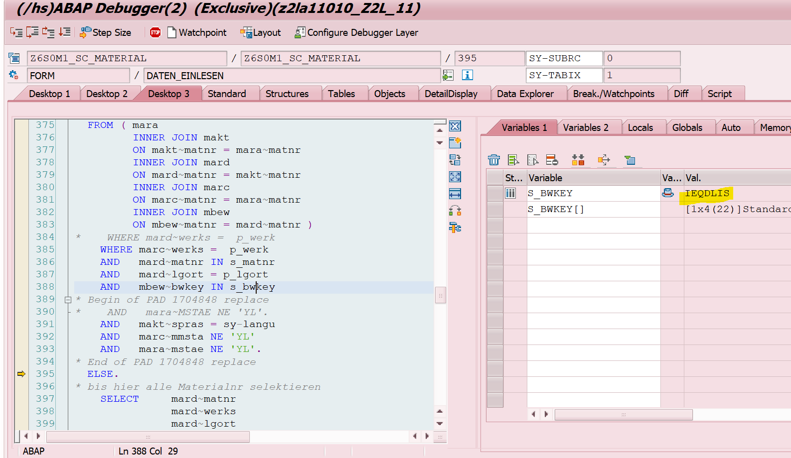
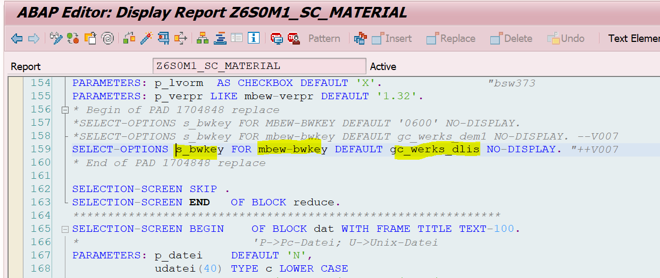
Earlier it was DEM1 as constant but it was changes to DLIS because of the azure task
179235_Enterprise Project - Trans analys.

